**16**

**Wave Motion**

|  |
| --- |
| **CHAPTER OUTLINE** |

16.1 Propagation of a Disturbance

16.2 Analysis Model: Traveling Wave

16.3 The Speed of Transverse Waves on Strings

16.4 Rate of Energy Transfer by Sinusoidal Waves on Strings

16.5 The Linear Wave Equation

16.6 Sound Waves

16.7 Speed of Sound Waves

16.8 Intensity of Sound Waves

16.9 The Doppler Effect

* An asterisk indicates a question or problem new to this edition.

|  |
| --- |
| **SOLUTIONS TO THINK-PAIR-SHARE AND ACTIVITIES** |

**\*TP16.1** **Conceptualize** Figure 16.4 shows a typical wind-driven wave on the surface of the ocean. A tsunami would be similar to this diagram, except that the wavelength would be huge compared to normal ocean waves.

**Categorize** The waves on the ocean, whether wind-driven or tsunami, are described by the *traveling wave* model.

**Analyze**  (a) Let us first use the traveling wave model to calculate the frequency of the wave:



Inverting this result, the period of the tsunami is 0.25 h, or 15 minutes. Therefore, on the ship in the ocean, the passage of the tsunami would be represented by your ship moving up and down by the crest-to-trough vertical distance of 2.0 m in 15 minutes. This is essentially undetectable, especially in the presence of the motion of the ship due to the normal wind-driven waves.

(b) Based on our frequency calculation of part (a), if the water begins to recede at a given time, it will begin coming back in about half the period, or 7.5 minutes, so you have about that much time to warn people to move off the beach and head far inland to high ground.

(c) Set up a ratio of the power of the wave in the open ocean to the power in the shallow water:

 (1)

Introduce two facts into this equation: (1) our assumed conservation of energy means that *P*shallow = *P*deep, and (2) the frequency of a wave does not change when it enters a new medium, so **shallow = **deep. Therefore,

 (2)

Solve for the amplitude of the wave in the shallow water:

 (3)

Substitute numerical values:



(d) If half the energy is reflected, then only half the power is transmitted into the shallow water, so Equation (2) is modified to be

 (4)

Solve for the amplitude of the wave in the shallow water:

 (5)

Substitute numerical values:



**Finalize** The amplitude in part (d) is still very dangerous. Keep in mind that the water in a tsunami arriving on shore will not just reach heights above sea level equal to the amplitude. The tremendous amount of momentum in the water will cause it to rise up the slope of a beach and well into any buildings and houses in a developed area located there. The moving water can cause great damage both as it enters the area and also as it recedes back into the ocean.

*Answers:* (a) Wave is undetectable. (b) 7.5 min (c) 3.3 m (d) 2.3 m

**\*TP16.2 Conceptualize** Imagine the sound waves spreading out from the speaker as suggested by Figure 16.21. Any sound waves aimed toward the ground are absorbed, so we don't need to worry about those.

**Categorize** We categorize the sound waves as spherical and use the discussion in Section 16.8.

**Analyze** (a) Use Equation 16.40 and determine the intensity from 16.41 to find the power output of the speaker:

 (1)

Substitute numerical values:



(b) Substitute new numerical values into Equation (1):



(c) The power found in part (b) is clearly less than the desired 25 W and much less than the 150 W figure stated by the salesman. Hopefully, however, after doing some research, you learned the following: loudspeakers are rated in electronics stores by the *input* electrical power. That is the figure given by the salesman. That number is far different, however, from the *output* sound power. Loudspeakers have an efficiency of about 1%. Therefore, for the 150 W of input electrical power, about 1.50 W of sound power comes out, agreeing with the result in part (b). The rest of the input energy goes into warming up the loudspeaker and the air surrounding it.

**Finalize** The salesman was just doing his job. It’s the entrepreneur’s responsibility to understand the difference between input electrical power and output sound power for the loudspeakers.

*Answers:* (a) 25.1 W (b) 1.51 W (c) Answers will vary.

**\*TP16.3 Conceptualize** Imagine the earthquake occurring, with waves spreading out in all directions along the surface of the Earth. In particular, think about the waves that will arrive at Sacramento, San Francisco, and Los Angeles.

**Categorize** While we might want to use the traveling wave model, we have no information about wavelengths or frequencies. What we have is a leading edge of the wave traveling through the Earth at a fixed speed. Therefore, we can model the leading edge of the wave as a *particle under constant velocity*.

**Analyze** From Equation 2.7, the time at which the leading edge a wave arrives at the seismic station, if the earthquake occurred at *t* = 0, is given by



where *d* is the distance between the earthquake epicenter and the seismic station. For the P and S waves, we don’t know the actual value of *t* because we don't know when the earthquake occurred. But we do know *two* values of *t* relative to an unknown reference time: one for the P waves and one for the S waves. So let’s subtract the arrival times:



Substituting the wave speeds, we have



Using this equation, we can subtract to find the S–P time difference and then find the distance from the epicenter to each of the seismic stations:

|  |  |  |  |  |
| --- | --- | --- | --- | --- |
| **Seismic Station** | **Arrival Time of P Wave (h:min:s)** | **Arrival Time of S Wave (h:min:s)** | ***t*S – *t*P (s)** | ***d* (km)** |
| Sacramento | 3:21:34.4 PM | 3:22:04.8 PM | 30.4 | 243 |
| San Francisco | 3:21:35.9 PM | 3:22:07.8 PM | 31.9 | 255 |
| Los Angeles | 3:21:52.1 PM | 3:22:40.2 PM | 48.1 | 385 |

Find a California map on the Internet that contains a scale. Using the scale, determine the radii of the three circles that you would draw centered on Sacramento, San Francisco, and Los Angeles representing the points from which the earthquake could have originated. Such a drawing appears below:

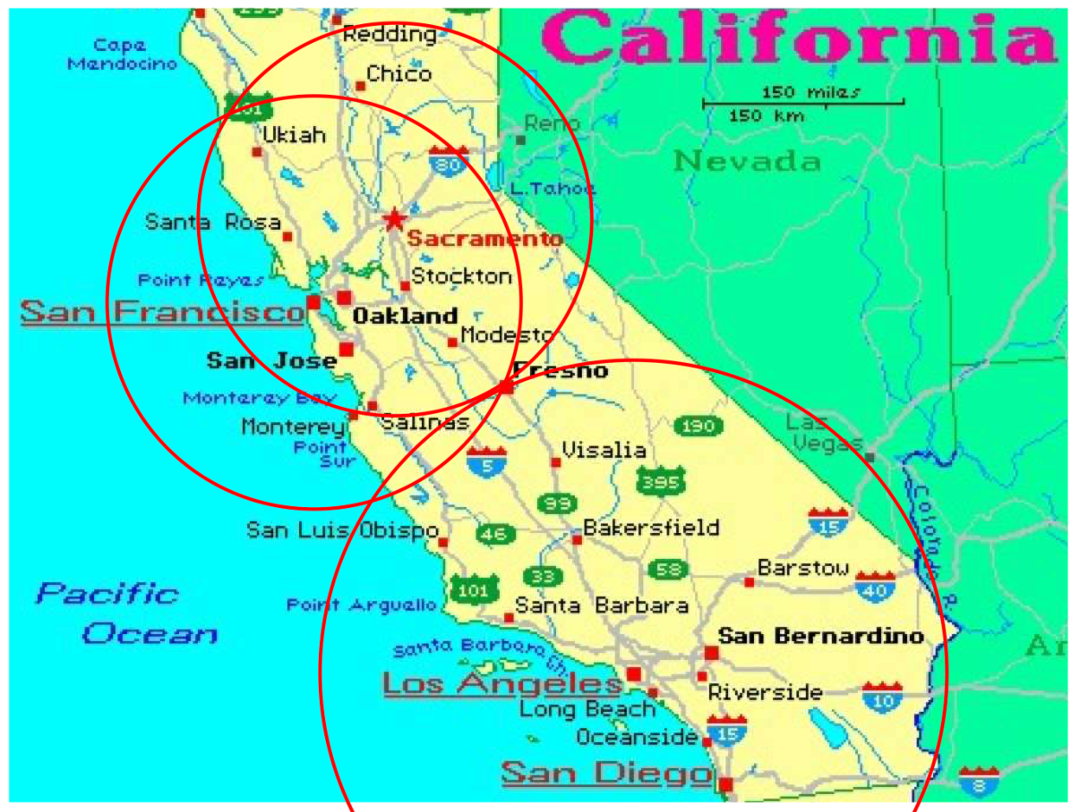

There is only one point belonging to all three circles, showing that the earthquake epicenter is near the city of Fresno, California.

(b) Because the primary wave travels at exactly twice the speed of the S wave, the S–P time difference is exactly the same as the time interval between the occurrence of the earthquake and the arrival of the leading edge of the P wave. Therefore, in the table, subtract the S–P time difference from the arrival time of the P wave:

|  |  |  |  |  |
| --- | --- | --- | --- | --- |
| **Seismic Station** | **Arrival Time of P Wave (h:min:s)** | **Arrival Time of S Wave (h:min:s)** | ***t*S – *t*P (s)** | **Time of earthquake**  **(h:min:s)** |
| Sacramento | 3:21:34.4 PM | 3:22:04.8 PM | 30.4 | 3:21:04.0 |
| San Francisco | 3:21:35.9 PM | 3:22:07.8 PM | 31.9 | 3:21:04.0 |
| Los Angeles | 3:21:52.1 PM | 3:22:40.2 PM | 48.1 | 3:21:04.0 |

All three sets of data show that the earthquake occurred at 3:21:04.0 PM.

**Finalize** Notice that the two circles centered on Sacramento and San Francisco would isolate the earthquake to two possible locations: Fresno and a point to the northwest of Ukiah. We need the third circle to identify which of these two locations is the correct one.

*Answers:* (a) Fresno (b) 3:21:04.0

|  |
| --- |
| **SOLUTIONS TO END-OF-CHAPTER PROBLEMS** |

Section 16.1 Propagation of a Disturbance

**P16.1** The distance the waves have traveled is *d* = (7.80 km/s)*t* =   
(4.50 km/s)(*t* + 17.3 s), where *t* is the travel time for the faster wave.

Then, 

or 

and the distance is 

**P16.2** (a) The  travels a shorter distance and is moving faster, so it will arrive at point *B* first.

(b) The P wave that travels through the Earth must travel

a distance of 

at a speed of 7 800 m/s.

Therefore, it takes 

The Rayleigh wave that travels along the Earth’s surface must travel a distance of



at a speed of 4 500 m/s.

Therefore, it takes 

The time difference is 

**\*P16.3 Conceptualize** Notice that the speed of sound in the pipe is much higher than the speed of sound in air. Therefore, you will hear the sound through the pipe first, followed later by the sound through the air. The time interval between the sounds will be short, which is why you will need your smartphone to measure them.

**Categorize** The sound pulses through the air and the pipe can each be modeled as a *particle under constant velocity.*

**Analyze** (a) Use Equation 2.7 to find the time at which each pulse arrives at the end of the pipe, where the initial position of the pulse at the struck end is *xi* = 0 and the final position of the pulse is *xf* = *L*, the length of the pipe:

 (1)

Find the time interval ∆*t* between the arrivals of the pulses for the two sound waves:



Substitute numerical values:

 (3)

(b) Substitute the numerical value for the time interval into Equation (3):



(c) Assuming that the speeds of sound are correct, the 1.0% error in the time interval will translate to a 1.0% error in the length measurement:



**Finalize** Your supervisor may or may not be happy with the half-meter uncertainty expressed in part (b). On the other hand, he may be willing to accept that uncertainty in exchange for the much faster measurement time for your technique. Your technique may also have other uncertainties. For example, the speed of sound will depend on temperature, so you would need to take that into account in your measurement.

*Answers:* (a)  (b) 48.2 m (c) 48 cm

**\*P16.4 Conceptualize** You are likely to have seen a wave at a stadium; they are common all over the world. If not, videos are available online. While it is called a “wave,” it is actually a single pulse.

**Categorize** For lack of any information to the contrary, we will model the wave as a *particle under constant speed*.

**Analyze** The speed of the wave, in seats per second, is



When the wave arrives at a certain seat, the person in that seat begins to rise and then sit down. During the time interval of standing and sitting, the wave has progressed at its speed across more seats. By the time you sit down, the leading edge of the wave is arriving at a distance from you of



Therefore, 19 or 20 people are up out their seats and not paying attention to buying concessions.

**Finalize** This result applies to only one row. We can’t simply multiply by the number of rows, because different rows will have different numbers of seats, but we can argue that at least several hundred people in the stadium are up out of the seats at any time during a wave, cutting onto concession sales.

Answer: 19 or 20 people

**Section 16.2 Analysis Model: Traveling Wave**

**P16.5** The speed of waves along this wire is



**P16.6** (a) ANS. FIG. P16.6 shows the *y* vs. *t* plot of the given wave.

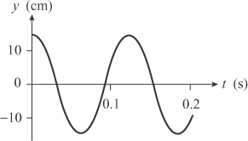

**ans. FIG. P16.6**

(b) The time from one peak to the next one is



(c) 

**P16.7** At time *t*, the motion at point *A*, where *x* = 0, is



At point *B*, the motion is



which implies



or 

P16.8 (a) ANS. FIG. P16.8 (a) shows a sketch of the wave at *t* = 0.

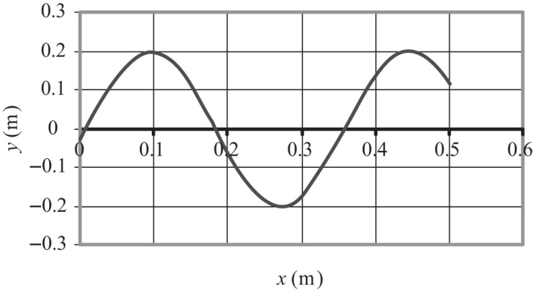

**ans FIG. P16.8 (a)**

(b) 

(c) 

(d) 

(e) 

(f)  specializes to



(g) At x = 0, t = 0 we require



so



**P16.9** Using the traveling wave model, we can put constants with the right values into  to have the mathematical representation of the wave. We have the same (positive) signs for both *kx* and *ωt* so that a point of constant phase will be at a decreasing value of *x* as *t* increases—that is, so that the wave will move to the left.

The amplitude is *A* = *y*max = 8.00 cm = 0.080 0 m

The wave number is 

The angular frequency is 

(a) In  choosing *φ* = 0 will make it true that   
*y*(0, 0) = 0. Then the wave function becomes upon substitution of the constant values for this wave



(b) In general, **

If *y*(*x*, 0) = 0 at *x* = 0.100 m, we require

**

so we must have the phase constant be 

Therefore, the wave function for all values of *x* and *t* is



**Section 16.3 The Speed of Waves on Strings**

**P16.10** If the tension in the wire is *T*, the tensile stress is



The speed of transverse waves in the wire is



where *ρ* is the density. The maximum velocity occurs when the stress is a maximum:



**P16.11** The two wave speeds can be written as



Since  is constant,  and



**P16.12** The tension in the string is *T* = *mg*, where *g* is the acceleration of gravity on the Moon, about one-sixth that of Earth. From the data given, what is the acceleration of gravity on the Moon?

The wave speed is







**P16.13** (a) The tension in the string is



Then, from  the mass per unit length is



(b) When *m* = 2.00 kg, the tension is



and the speed of transverse waves in the string is



**Section 16.4 Rate of Energy Transfer by Sinusoidal Waves on Strings**

**P16.14** We use  to solve for the tension:



**P16.15** We are given T = constant; we use the equation for the speed of a wave on a string,  and the power supplied to a vibrating string, 

(a) If *L* is doubled, *μ* is still the same, so v remains constant: therefore *P* is constant: 

(b) If *A* is doubled and *ω* is halved,  remains constant: 

(c) If *λ* and *A* are doubled, the product  remains constant, so 

(d) If *L* and *λ* are halved, *μ* is still the same, and  is quadrupled, so *P* 

**P16.16** (a) 

(b) We write *P* = *FvA*2, where *F* is some constant. With no absorption of energy,





**P16.17** We are given  with



(a) From , 

(b) 



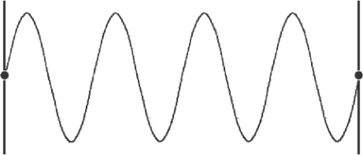

**ans. FIG. P16.17**

**P16.18** Suppose that no energy is absorbed or carried down into the water. Then a fixed amount of power is spread thinner farther away from the source. It is spread over the circumference 2*π r* of an expanding circle. The power-per-width across the wave front



is proportional to amplitude squared, so amplitude is proportional to



**P16.19** Originally,



The doubled string will have doubled mass per length. Presuming that we hold tension constant, it can carry power larger by  times:



**Section 16.5 The Linear Wave Equation**

**P16.20** The important thing to remember with partial derivatives is that **you** **treat** **all** **variables** **as** **constants,** **except** **the** **single** **variable** **of** **interest**. Keeping this in mind, we must apply two standard rules of differentiation to the function *y* = ln[*b*(*x* − *vt*)]:

 **[1]**

 [2]

Applying [1],



Applying [2],



In a similar way,



From the second-order partial derivatives, we see that it is true that



so the proposed function **is** one solution to the wave equation.

**P16.21** The linear wave equation is 

If *y* = *eb*(*x*−*vt*)

Then  and 

 and 

Therefore,  demonstrating that *eb*(*x*−*vt*) is a solution.

**P16.22** (a) From 

evaluate  and 

Also,  and 

Does ?

By substitution, we must test  and this is true, so the wave function does satisfy the wave equation.

(b) Note



as required. So



(c) *y* = sin *x* cos *vt* makes

 

 

Then  becomes  which is true, as required.

Note 



So  with



**Section 16.6 Sound Waves**

P16.23 (a) 

(b) 

(c) 

(d) 

(e) 

**Section 16.7 Speed of Sound Waves**

P16.24 The speed of longitudinal waves in a fluid is  Considering the Earth’s crust to consist of a very viscous fluid, our estimate of the average bulk modulus of the material in Earth’s crust is



P16.25 We use 



P16.26 (a) 

(b) 

(c) 

*P16.27 **Conceptualize** The sound from the clap travels to the cliff and back, so the distance traveled by the sound is twice the distance to the cliff.

**Categorize** The pulse of sound from the clap will be modeled as a *particle under constant speed*.

**Analyze** Several sites are available online for calculating the distance between two coordinates. A typical value for a distance between the coordinates given in the problem is 78.8 m.

From this value, calculate the speed of sound:



**Finalize** This is surprisingly close, differing from the speed of sound at 20° by a little over 2%. Of course, we have no information about the temperature of the air on the day you perform the experiment, so we don’t really know the actual value of the speed of sound.

*Answer:* 335 m/s

P16.28 It is easiest to solve part (b) first:

(b) The distance the sound travels to the plane is



The sound travels this distance in 2.00 s, so



giving the altitude of the plane as 

(a) The distance the plane has traveled in 2.00 s is



Thus, the speed of the plane is:



P16.29 (a) At 9 000 m,  so *T* = –30.0°C.

Using the chain rule,



so . Integrating,



which gives  for sound to reach the ground.

(b)  

P16.30 Since ,  (each sign applying half the time),



Therefore,



**Section 16.8 Intensity of Sound Waves**

P16.31 We use 

(a) At *f* = 2 500 Hz, the frequency is increased by a factor of 2.50, so the intensity (at constant *s*max) increases by (2.50)2 = 6.25.

Therefore, 

(b) The changes cancel each other: frequency  and displacement amplitude 

original intensity: 

new intensity: 

P16.32 The original intensity is 

(a) If the frequency is increased to *f*′ while a constant displacement amplitude is maintained, the new intensity is

 so 

or 

(b) If the frequency is reduced to  while the displacement amplitude is doubled, the new intensity is



or the .

P16.33 (a) From the sound level equation,





We have assumed the speaker is an isotropic point source.

(b) Again from the sound level equation,





We have assumed a uniform medium that absorbs no energy.

P16.34 (a) The energy transferred by sound from the explosion is



(b) 

*P16.35 **Conceptualize** As the audience members climb up the ladder steps, they are moving closer to the loudspeakers. As a result, the intensity of the sound they hear increases, as does the sound level.

**Categorize** We are told that the sound is emitted uniformly in all directions, so we can use the discussion in Section 16.8 to help us with this problem.

**Analyze** Based on Equation 16.40, we can relate the intensity measured near the speakers to that located below the speakers a distance *r*:

 (1)

Rearrange Equation 16.41 so that it expresses the intensity in terms of the sound level:

 (2)

Use Equation (2) to substitute for the two intensities in Equation (1):

 (3)

Substitute numerical values, to find the distance from the speaker at which the sound level is at the threshold of pain, 120 dB:



This is the distance of the audience member from the speaker at which he hears the sound at the threshold of pain. We need to subtract this from the height of the speaker to find the height above the ground at which to mount the barriers:



**Finalize** Even hearing sound at sustained levels of 120 dB can be damaging to your hearing. Many people who attend rock concerts (as well as the performers) suffer hearing loss due to these activities.

Answer: 4.28m

P16.36 

P16.37 We begin with  and  so



Also,  and  giving 

Then, 

**Section 16.9 The Doppler Effect**

P16.38 (a) Equation 16.46, , applies to an observer on  because B is receiving sound from source A.

(b) The sign of *vs* should be  because the source is moving toward the observer, resulting in an increase in frequency.

(c) The sign of *vo* should be  because the observer is moving away from the source, resulting in a decrease in frequency.

(d) The speed of sound should be that of the medium of seawater, 

(e) 

P16.39 The *half angle* of the shock wave cone is given by 



P16.40 The apparent frequency drops because of the Doppler effect. Using a *T* subscript for the situation when the athlete moves *toward* the horn, and *A* for movement away from the horn, we have,



where *v*0 is the constant speed of the athlete. Setting this ratio equal to 5/6, we have



Solving for the speed of the athlete,

 

P16.41 (a) The maximum speed of the speaker is described by



The frequencies heard by the stationary observer range from



to

(b) 

(c) 

The maximum intensity level *β*max = 60.0 dB occurs at *r* = *r*min = 1.00 m. The minimum intensity level occurs when the speaker is farthest from the listener, i.e., when *r* = *r*max = *r*min + 2*A* = 2.00 m.

Thus, 

or



This gives:

  
or 

P16.42 The maximum speed of the speaker is described by



The frequencies heard by the stationary observer range from

(a)  to (b) 

where *v* is the speed of sound.

(c) 

The maximum intensity level *β*max = *β* occurs at *r* = *r*min = *d*. The minimum intensity level occurs when the speaker is farthest from the listener, i.e., when *r* = *r*max = *r*min + 2*A* = *d* + 2*A*.

Thus,



or



This gives:



or 

Additional Problems

P16.43 The speed of the wave on the rope is  and in this case *T* = *mg*; therefore, .

Now *v* = *fλ* implies  so that



P16.44 Assume a typical distance between adjacent people ~ 1 m.

Then the wave speed is 

Model the stadium as a circle with a radius of order 100 m. Then, the time for one circuit around the stadium is



P16.45 At normal body temperature of *T* = 37.0°C, the speed of sound in air is



and the wavelength of sound having a frequency of *f* = 20 000 Hz is



Thus, the diameter of the eardrum is 

P16.46 (a) 

(b) 

(c) For the wave described, with a single direction of energy transport, the power is the same at the deep-water location ➀ and at the place ➁ with depth 9.00 m. Because power is proportional to the square of the amplitude and the wave speed, to express the constant power we write,



(d) 

P16.47 (a) From *y* = (0.150 m) sin (0.800*x* – 50.0*t*) = *A* sin (k*x* – *ω t*)

we compute



and 

Then 

(b) For the 1.00-cm segment with maximum force acting on it,



(c) To find the tension in the string, we first compute the wave speed



then,





**P16.48** Imagine a short transverse pulse traveling from the bottom to the top of the rope. When the pulse is at position *x* above the lower end of the rope, the wave speed of the pulse is given by  where  is the tension required to support the weight of the rope below position *x*.

Therefore, 

But , so that 

and 

**P16.49** (a) 



With all SI units,



(b) 



P16.50 





P16.51(a) 

(b) 

(c) 

**P16.52** (a) We have  and  We then have





(b) 



P16.53 The gliders stick together and move with final speed given by momentum conservation for the two-glider system:



The missing mechanical energy is



We imagine one-half of 227 mJ going into internal energy and half into sound radiated isotropically in 7.00 ms. Its intensity 0.800 m away is



Its intensity level is





P16.54 (a) 

(b) 

(c) 

(d) 

(e) 

(f) 

(g) 

P16.55 For the longitudinal wave 

For the transverse wave 

If we require , we have  where  and



This gives



**P16**.56 (a) Model your loud, sharp sound impulse as a single narrow peak in a graph of air pressure versus time. It is a noise with no frequency, wavelength, or period. It radiates away from you in all directions and some of it is incident on each one of the solid vertical risers of the bleachers.



Suppose that, at the ambient temperature, sound moves at 343 m/s; and suppose that the horizontal width of each row of seats is 60 cm. Then there is a time delay of



between your sound impulse reaching each riser and the next. Whatever its material, each will reflect much of the sound that reaches it. The reflected wave sounds very different from the sharp pop you made.

(b) If there are twenty rows of seats, you hear from the bleachers a tone with twenty crests, each separated from the next in time by



This is the extra time for it to cross the width of one seat twice, once as an incident pulse and once again after its reflection. Thus, you hear a sound of definite pitch, with a period of about 0.0035 s, and frequency,



(c) Wavelength



(d) and duration



**Challenge Problems**

P16.57(a)  is a linear function, so it is of the form 

To have  we require  Then 

so 

Then 

(b) Imagine the crest of a short transverse pulse traveling from one end of the string to the other. Consider the pulse to be at position x. From  the time interval required to move from *x* to   
*x* + *dx* is  The time interval required to move from 0 to *L* is



P16.58Refer to Problem 60. At distance *x* from the bottom, the tension is  so the wave speed is:



(a) Then



gives 





(b) When *M* = 0,



(c) As  we expand



to obtain 



where we neglect terms  and higher because terms with m2 and higher powers are very small.

P16.59 Figure 17.10 shows that each wavefront that passes the observer is spherical. Let T represent the period of the source vibration, and TMW be the energy put into each wavefront during one vibration. Then  At the moment when the observer is at distance *r* in front of the source, he is receiving a spherical wavefront of radius

 where  is the time interval since this energy was radiated. Since the wavefront was radiated, the source has moved forward distance  so the total distance the wavefront has traveled is



therefore,



The surface area of the sphere is . The energy per unit area emitted during one cycle and carried by one spherical wavefront is uniform with the value



The energy carried by the wavefront passes the observer in the time interval T′ = 1/f′, where f′ is the Doppler-shifted frequency



so the observer receives a wave with intensity



**P16.60** (a) ANS. FIG. P16.60 shows a force diagram of an element of gas indicating the forces exerted on the left and right surfaces due to the pressure of the gas on either side of the element.

(b) Let *P*(*x*) represent absolute pressure as a function of x. The net force to the right on the chunk of air is  Atmospheric pressure subtracts out, leaving



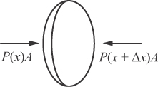

**ANS. FIG. P16.60**

The mass of the air is  and its acceleration is . So Newton’s second law becomes



(c) From the result above, we have



Substituting  (Eq. 16.30), we have



(d) Into this wave equation we substitute a trial solution   
 We find



 becomes



This is true provided that , that is, provided it propagates with speed .

|  |
| --- |
| **ANSWERS TO QUICK-QUIZZES** |

**1.** (i) (b) (ii) (a)

**2.** (i) (c) (ii) (b) (iii) (d)

**3.** (c)

**4.** (f) and (h)

**5.** (d)

**6.** (c)

**7.** (b)

**8.** (b)

**9.** (e)

**10.** (e)

**11.** (b)

|  |
| --- |
| **ANSWERS TO EVEN-NUMBERED PROBLEMS** |

P16.2 (a) longitudinal P wave; (b) 666 s

P16.4 19 or 20 people

P16.6 (a) See ANS FIG P16.6; (b) 0.125 s; (c) This agrees with the period found in the example in the text.

P16.8 (a) See ANS FIG P16.8 (a); (b) 18.0 rad/m; (c) 0.083 3 s; (d) 75.4 rad/s;   
(e) 4.20 m/s; (f) ; (g) *y*(*x, t*) = 0.200 sin (18.0*x* + 75.4*t –* 0.151), where *x* and *y* are in meters and *t* is in seconds.

P16.10 185 m/s

P16.12 The calculated gravitational acceleration of the Moon is almost twice that of the accepted value.

P16.14 631N

P16.16 (a) As for a string wave, the rate of energy transfer is proportional to the square of the amplitude to the speed. The rate of energy transfer stays constant because each wavefront carries constant energy, and the frequency stays constant. As the speed drops, the amplitude must increase; (b) The amplitude increases by 5.00 times

P16.18 See P16.18 for the full explanation.

P16.20 The proposed function **is** one solution to the wave equation

P16.22 (a) See P16. 22 (a) for full explanation; (b)  and ; (c)  and 

P16.24 1 × 1011 Pa

P16.26 (a) The speed gradually changes from   
*v* = (331 m/s)(1 + 27°C/273°C)1/2 = 347 m/s to   
(331 m/s) (1 + 0/273°C)1/2 = 331 m/s, a 4.6% decrease. The cooler air at the same pressure is more dense; (b) The frequency is unchanged because every wave crest in the hot air becomes one crest without delay in the cold air; (c) The wavelength decreases by 4.6%, from *v/f* = (347 m/s) (4 000/s) = 86.7 mm to (331 m/s)(4 000/s) = 82.8 mm. The crests are more crowded together when they move more slowly.

P16.28 (a) 153 m/s; (b) 614 m

P16.30 See P16.30 for complete solution.

P16.32 (a) ; (b) intensity is unchanged

P16.34 (a) 1.76 kJ; (b) 108 dB

P16.36 We assume that both lawn mowers are equally loud and approximately the same distance away. We found in Example 16.8 that a sound of twice the intensity results in an increase in sound level of 3 dB. We also see from the What If? section of that example that a doubling of loudness requires a 10-dB increase in sound level. Therefore, the sound of two lawn mowers will not be twice the loudness, but only a little louder than one!

P16.38 (a) B; (b) positive; (c) negative; (d) 1 533 m/s; (e) 5.30 × 103 Hz

P16.40 This is much faster than a human athlete can run.

P16.42 (a)  (b)  (c) 

P16.44 ~1 min

P16.46 (a) The energy a wave crest carries is constant in the absence of absorption. Then the rate at which energy passes a stationary point, which is the power of the wave, is constant; (b) The power is proportional to the square of the amplitude and to the wave speed. The speed decreases as the wave moves into shallower water near shore, so the amplitude must increase; (c) 8.31 m; (d) As the water depth goes to zero, our model would predict zero speed and infinite amplitude. In fact, the amplitude must be finite as the wave comes ashore. As the speed decreases, the wavelength also decreases. When it becomes comparable to the water depth, or smaller, our formula  for wave speed no longer applies.

P16.48 

P16.50 The given speed corresponds to an ocean depth that is greater than the average ocean depth, about 4 280 m.

P16.52 (a) ; (b) 85.9 Hz

P16.54 (a) The wave moves outward equally in all directions; (b) Its amplitude is inversely proportional to its distance from the center. Its intensity is proportional to the square of the amplitude, so the intensity follows the inverse-square law, with no absorption of energy by the medium; (c) Its speed is constant . By comparison to the table, it can be moving through water at 25° C, and we assume it is; (d) Its frequency is constant at  (e) Its wavelength is constant at ;  
(f) ; (g) Its intensity follows the inverse-square law; at *r* = 1 m, the intensity is 

P16.56 (a) The repeated reflections from the steps create a repetition frequency so that the ear/brain combination assigns a pitch to the sound heard by the listener; (b) ~ a few hundred Hz; (c) ~ 1 m; (d) ~ 0.1 s

P16.58 (a) ; (b) ; (c) 

P16.60 (a) See ANS. FIG P16.60; (b) See P16.60(b) for full explanation; (c) See P16.60 (c) for full explanation; (d) See P16.60 (d) for full explanation.